Maths

Calculation Policy



AIMS OF THE POLICY
• To ensure consistency and progression in our approach to calculation and enable a smooth transition between year groups and phases.
• To ensure that children develop an efficient, reliable, formal written method of calculation for all operations.
• To ensure that children can use these methods accurately with confidence and understanding.
• To ensure pupils understand important concepts and make connections within mathematics.
• To ensure pupils show high levels of fluency in performing written and mental calculations.
• To ensure that pupils are ready for the next stage of learning and have been given strong foundations in mental methods, the use of practical equipment, allowed to explore jottings in a range of forms and then to move onto more formal recording using a strong knowledge of place value, number lines labelled or blank, partitioning before eventually using compact written methods.
• To ensure that pupils are competent in fluency, reasoning and problem solving and can make informed and appropriate choices about the methods they wish to use (mental or written) to solve mathematical problems efficiently and effectively.
INTRODUCTION
The policy is set out in subjects, addition, subtraction, multiplication and division. Within each specific area there is a progression of skills, knowledge and layout for written methods that has been agreed by all staff. The calculation strategies which will be used will reflect this ideology – moving from concrete to pictorial and then abstract recording leading to more formal written methods. Mental methods and strategies will work in partnership with these methods.
It has been agreed by all staff that a variety of mental calculation methods will be taught and that recall of facts will be taught in school and tested regularly. The progression of mental methods and expectations will comply with the new national curriculum statements 2014. (See Appendix 1).
The basis of our maths calculation policy is that mental and written methods are integral to each other and should not be seen as taking separate paths but developed in conjunction with each other. It is envisaged that the development of mental skills will lead to jottings, (which support mental calculation) and then into more formalised jottings in the form of number lines and partitioning which in turn leads to expanded column methods and ultimately compact algorithms.
It is important to always show the links between operations and not teach them in isolation or without showing, in practical problem solving activities and across all mathematical topics, how these operations can be applied.
It is important that staff always use correct mathematical language and encourage this from every pupil. This will take place in class discussions as well as through oral and written feedback, next steps and target setting.
We have chosen not to identify which year group should use which method because we wish staff and pupils to have the freedom to take the next steps on their mathematical journey when they are ready to do so and if the policy is followed, there should not be a problem with progression as pupils move through the school.
However a word of caution should be given here. All staff have the responsibility to make sure that pupils have the depth of knowledge and experiences required to move onto the next stage of their development rather than pushing them on too quickly. This, we have agreed, leads to misconceptions and poor mathematical foundations and eventually, in later years, pupils will not be able to make the required progress.
Ultimately we aim to enable pupils to make informed choices about the methods they use both mental and written that are the most efficient and this includes recognised compact methods.
EARLY FOUNDATIONS
- Number rhymes/ stories/ songs – Action rhymes.
- Sorting into sets.
- Matching:
- object - object
- object – picture
- picture – picture
- patterns
- Comparing
- Arranging/ organise items into sets.
- Sorting – 1 general set.
- Sorting for positive/ negative reasons.
- Sorting for specific reasons.
- Sorting for specific reasons chosen by the child.
- Order
- Objects which are bigger/ smaller.
- Ordering numerals on a washing line/ number line/ magnetic numbers.
- Sequencing
- Recognising patterns.
- Copying a pattern.
- Creating a pattern.
- Count
- Learn number words.
- Recognising some numerals.
- Counting how many?
- Recognising numbers
- Number formation practise.
- Flash cards.
- Number snap/ puzzles/ games.
- Magnetic numbers.
- Printing numbers.
- Painting numbers.
- Playdough numbers.
- Big Book work.
- Display work.
- IT programs.
ADDITION
Definition
Addition is the process of calculating the total of two or more numbers or amounts. It is the inverse of subtraction.
Early Learning
Using a range of practical resources and real life contexts, pupils develop their understanding of the concept of addition through counting activities. They then use pictures/diagrams to represent the calculation, for example Numicon:
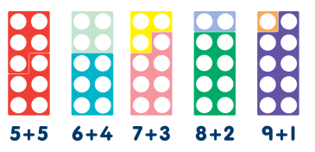
Children will engage in a wide variety of songs and rhymes, games and activities. They will begin to relate addition to combining two groups of objects, first by counting all and then by counting on from the largest number.
They will find one more than a given number.
In practical activities and through discussion they will begin to use the vocabulary involved in addition.
‘You have five apples and I have three apples. How many apples altogether?’
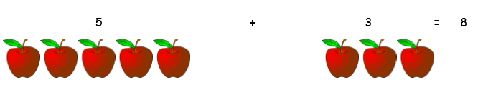
Mental Calculations
- Counting forwards and backwards.
- Understanding that addition is commutative.
- Partitioning.
- Recalling number bonds.
- Using subtraction as the inverse of addition.
ADDITION
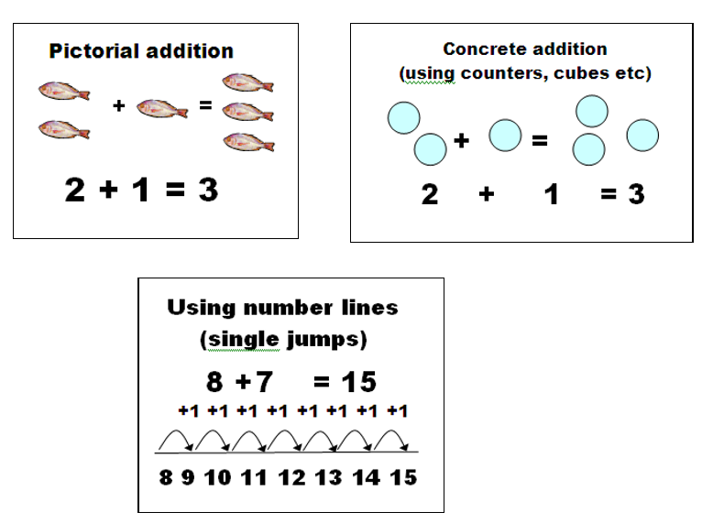
- Stress practical apparatus to support addition tasks, recording pictorially.
- Use practical apparatus to support addition tasks, recording pictorially.
- Use practical apparatus to investigate combinations of numbers up to 5, 10 using
- recognised recording of number sentences 4 + 3 = 7 such as Numicon:

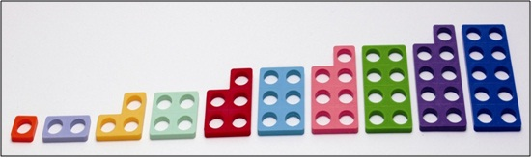

- Use printed number lines to show addition, eg:
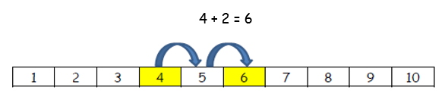
ACTIVITIES RELATED TO ADDITION
- Use 100 square to find 10 more than a given number.
- Stress the language of addition: more than, add, total, altogether, sum.
- Set challenges/ investigations related to addition.
- Pupils create their own ‘number sentences’ using dice, cards.
- Pupils create their own ‘number stories’ using practical equipment, eg If I had 3 apples and bought 3 more I would have 6 in total.
- Pupils encouraged to ‘guess’ the outcome – concept – addition will give a higher, bigger number.
- Addition can be done in any order – same total. Investigate this principle. Use the strategy of largest number first and count on.
- Note: Emphasis is placed on verbal reasoning, using mental strategies which are supported by written ‘jottings’ – pictures, number lines, drawing ‘sets’, as well as using practical apparatus, cubes, number of beads etc.
- Counting on in single digits. Also adding a multiple of 10 to a single or 2 digit number. (Lots of verbal counting and use of a number line and 100 square,
eg 13 + 10 = 23 (This mental concept should be practised until they are confident and they can apply this knowledge to written methods - pupils should not need to count up in ‘ones’ on a numberline).

Steps in addition can be recorded on a number line. The steps often bridge through a multiple of 10.
8 + 7 = 15
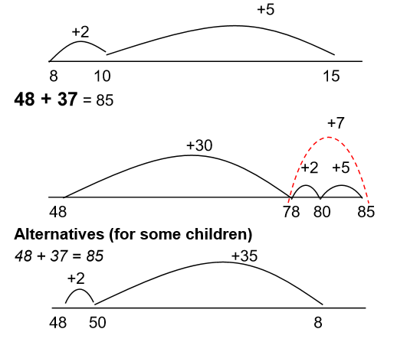
- Use practical and informal written methods to support addition of 2-digit numbers.
- Encourage the use of an ‘open’ number line. Pupils ‘hang’ their mental calculations on it.
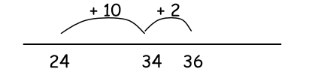
Note: These written ‘jottings’ work alongside mental calculation strategies.
a) Uses number bonds to 10.
b) Uses the ability to count on in multiples of 10 from any given number.
- Addition not bridging a 10, using brackets, partitioning into T.U. (links to place value).
24 + 21 = or
(20 + 20) = 40 24 + 20 = 44
(4 + 1) = 5 44 + 1 = 45
40 + 5 = 45
- Addition bridging 10: 40 + 20 = 60
3 + 8 = 11
60 + 11 = 71
- Addition counting on in multiples of 10 (linked to counting, use of 100 square, verbal questioning, place value):
43 + 28 =
43 + 20 = 63 + 8 = 71
- Addition – using adjustment: 43 + 29 =
43 + 30 = 73
73 – 1 = 72
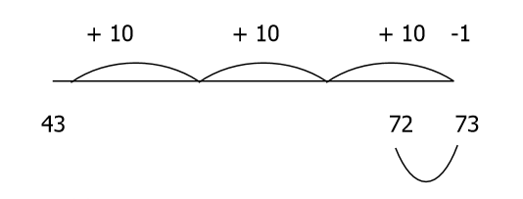
Record steps in addition using partitioning:
Initially as a jotting:
58 + 87 = 50 + 80 + 8 + 7 = 130 + 15 = 145
Or 50 + 80 = 130
8 + 7 = 15
130 + 15 = 145
Partitioned numbers are then written under one another
50 8
80 7
130 15 = 145
This method may be appropriate for some children with larger numbers if they struggle with earlier stages
500 30 8 2400 60 7
200 80 6 700 80 5
700 110 14 = 824 3100 140 12 = 3252
Adding the ones first: Simple examples to introduce the expanded method to the children.
Many children would continue to answer these calculations mentally or using a simple jotting
67
+ 24
11
80
91
Refine over time to adding the ones digits first consistently, with harder calculations
457 + 76
457
+ 76
13
120
400
533
The time spent practising expanded method will depend on security of number facts recall and understanding of place value.
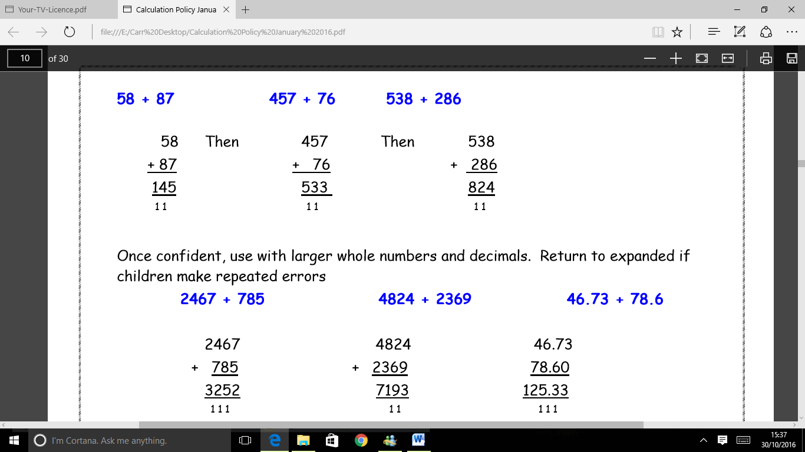
Once confident, use with larger whole numbers and decimals. Return to expanded if children make repeated errors

SUBTRACTION
Definition
Subtraction is the process or skill of taking one number or amount away from another or finding the difference between two numbers.
Early learning
Using a range of practical resources and real life contexts, pupils develop their understanding of the concept of subtraction through counting activities. They then use pictures/diagrams to represent the calculation.
E.g. There are 3 apples and 1 is eaten. How many are left?
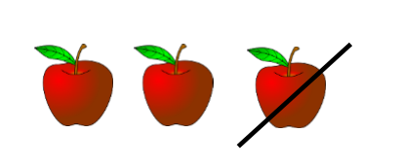
They may also use Numcion to represent the calculation, e.g. 9 -5:
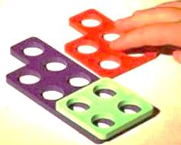
Mental Calculations
- Counting forwards and backwards in ones, twos, fives, tens etc.
- Partitioning: compensating. Subtracting 9 by subtracting 10 and adding 1.
- Partitioning: using near doubles.
- Using addition as the inverse of subtraction. Linking compliments to 10, 20 100 to subtraction.
Activities related to Subtraction
- Use of number lines – practical tasks – to ‘count back’.
- Use of number lines and practical tasks to find ‘one less’ than a given number.
- Introduction of the subtraction sign.
- Practical subtraction tasks.
- Recording subtraction in pictorial form linked to practical tasks – using – and = signs.
- Reinforcement of the language of subtraction: less than, difference, take away, subtract.
- Given a number, identify one less.
- Read, write and interpret mathematical statements involving subtraction
- (-) and the equals (=) sign.
- Subtract one- digit and two-digit numbers within 20, including zero.
- Solve missing number problems eg 20 - = 15.
- Set problems where the missing number is not always the answer so that pupils can explore written jottings to find the missing number but prove that the number sentence ‘makes sense’ and is reasonable – using addition or subtraction.
- Incorporate estimation skills and rounding to develop a clearer understanding of ‘where the answer should be’ – question their results.
- Apply these ‘jotting’ methods to word problems and number investigations.
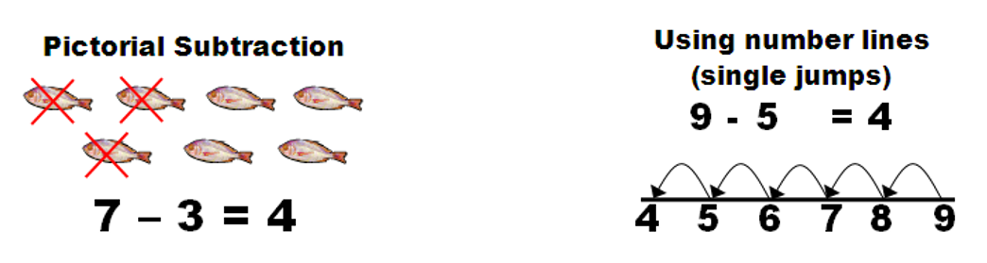
Subtract 1 digit numbers from one digit. Use a number line and count back.
Children will continue to practise counting back from a given number.
Initially use a number track to count back for subtraction:
9 - 5 = 4
‘Put your finger on number nine. Count back five.’
Subtract 1 digit numbers from 2 digits. Use a number line and
a) Count back without bridging a 10.
b) Count back and bridge a 10.
Relate to addition and number bands to 10, eg 17 - 6 = 11 because 1 + 6 = 7.
- Understand that subtraction is both:
a) Taking away – eg counting back on a number line, crossing out pictures and removing items from a tray.
b) Difference – eg counting on from the smaller number up to the larger number to find the ‘difference’ between them. Lots of practical activities showing towers of cubes next to each other.
c) The ‘difference’ between 5 and 2 is 3. Simultaneously track this on a number line. Start at the lower number and count on to find the difference or ‘the gap’ between the larger and the smaller number.
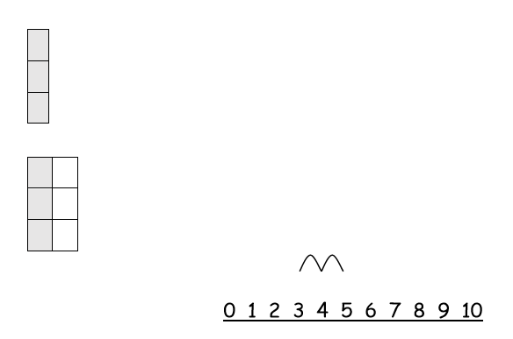
Complete number sentences 5 - 2 = 3 using a written number line or number track.
- Work on the language of subtraction is vital.
- Use practical and informal written methods to support subtraction of 2 digit numbers.
- Use a number line to ‘count on’ from the smallest number – finding the difference.
Note: Stress the link between addition and subtraction – showing one is the opposite or inverse of the other.
Small differences can be found by counting up
12 – 9 = 3
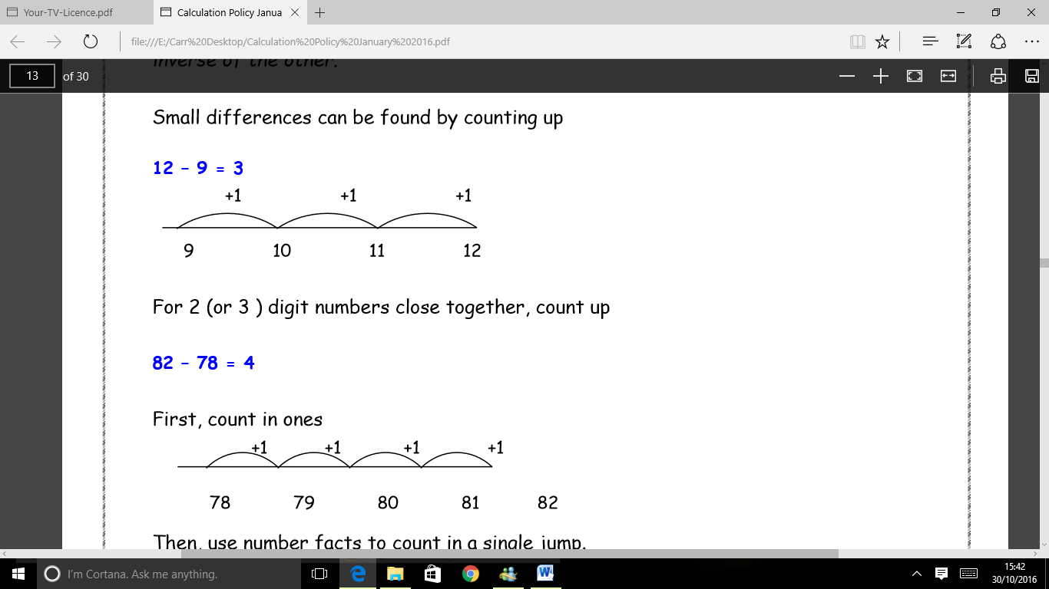
For 2 (or 3 ) digit numbers close together, count up
82 – 78 = 4
First, count in ones
Then, use number facts to count in a single jump.
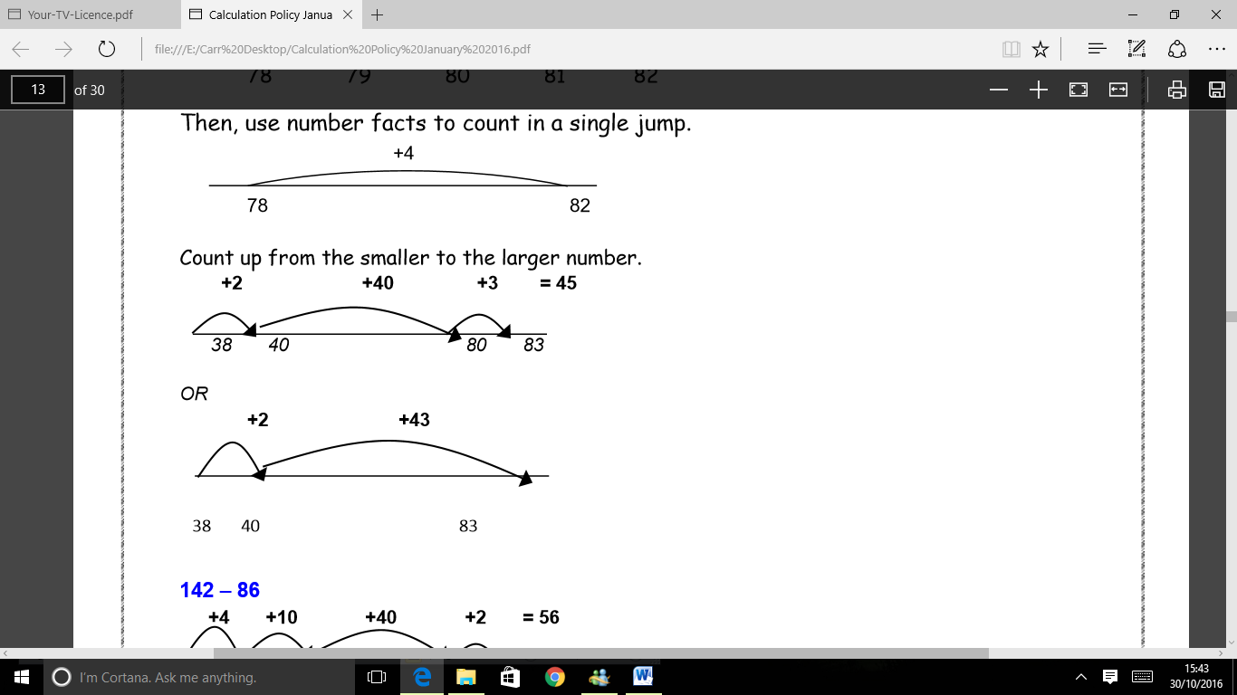
Count up from the smaller to the larger number.
142 – 86
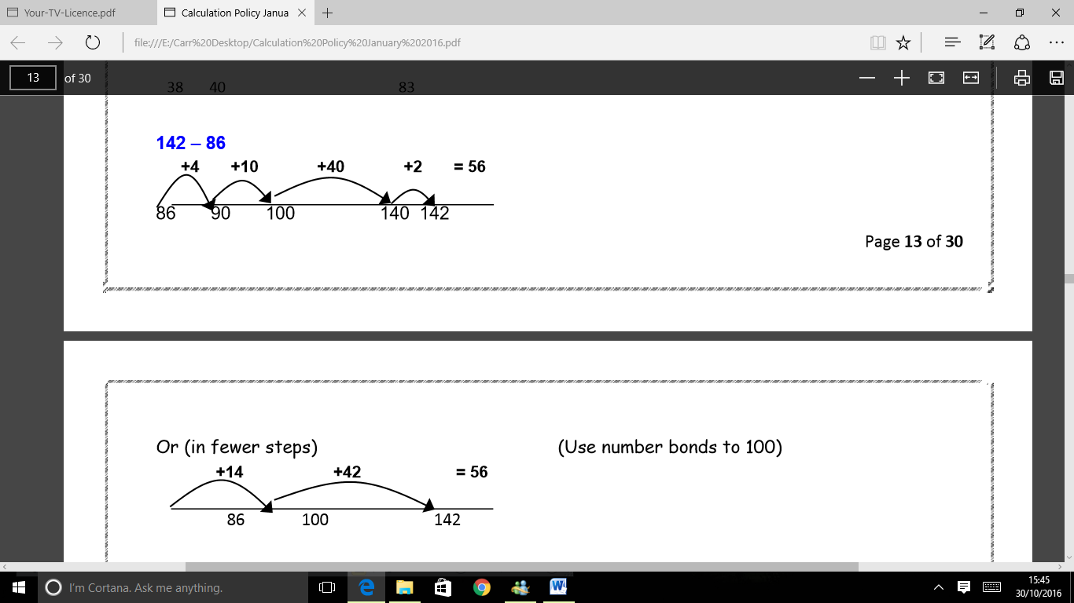
Or (in fewer steps) (Use number bonds to 100)
The ‘counting on’ or ‘finding the difference’ number line method can be used for larger numbers, or numbers with zeros that create problems when exchanging or for decimals. If pupils are comfortable with this method and understand place value especially with decimals they can revert back to using a number line for certain problems even if they have moved on to expanded column methods.
605 – 328
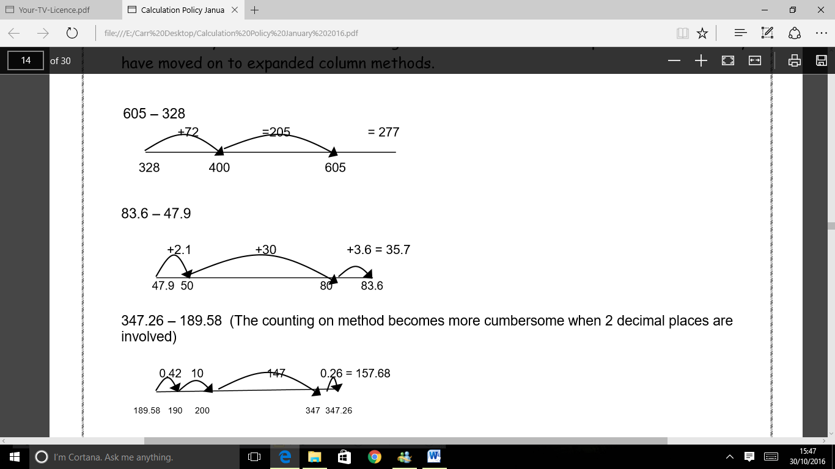
347.26 – 189.58 (The counting on method becomes more cumbersome when 2 decimal places are involved)
Introduce the expanded method with 2 digit numbers to explain the process.
Partition both numbers into tens and ones. Pupils MUST be confident with place value and partitioning of numbers. Practical equipment should be used to show how amounts can be ‘exchanged’ NOT ‘borrowed’ and pupils should be aware that the ‘amount’ is still the same but just represented in a different way. Nothing has been ‘lost’
Exchange from the tens to the ones.
83 – 38
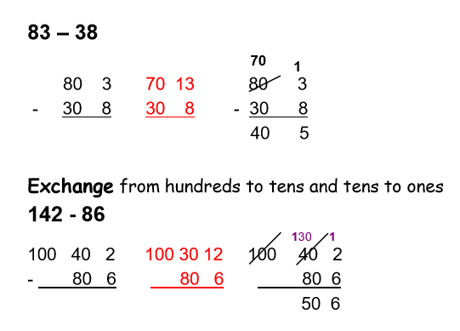
Take the method into three digit numbers
Subtract the ones then the tens then the hundreds
Demonstrate without exchanging first
784 - 351
700 80 4
- 300 50 1
400 30 3
Move towards exchanging from hundreds to tens and tens to ones
854 - 286
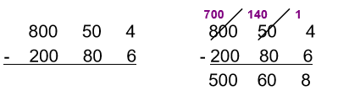
Use some examples which include the use of zeros
605 – 328
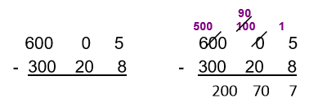

Decomposition relies on secure understanding of the expanded method, and simply displays the same numbers in a contracted form.
854 – 286
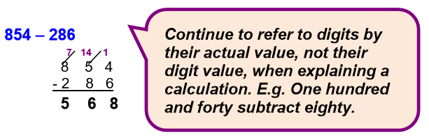
Again, use examples containing zeros, remembering that it may be easier to count on with these numbers
605 – 328
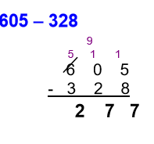
MULTIPLICATION
Definition
Multiplication is the product of two numbers or repeatedly adding the same set of number
as many times as the other number. Therefore 3 multiplied by 4 is 4 lots of 3, or 3 added
repeatedly 4 times. It is an inverse operation of division.
Early Learning
Pupils are given an opportunity to manipulate and experience a range of resources in real
life contexts and through role play. They are encouraged to solve real life problems e.g.
If one pair of welly boots = 2 then 3 pairs = 6
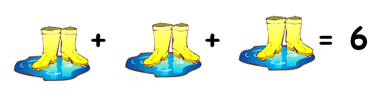
They are encouraged to draw pictures and represent their mathematical thinking through
various representations e.g. bead strings, numicon, cubes.
Finding doubles- Double 5 equals 10
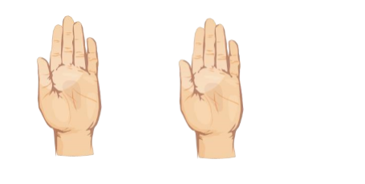
Mental Calculations
- Counting forwards and backwards in equal steps e.g. in 2’s, 5’s, 10’s.
- Repeated addition.
- Rapid recall of multiplication facts.
- Partitioning. Find 12 x 8 by using 10 x 8 (80) and 2 x 8 (16).
- Secure understanding of place value.
- Multiplying and dividing by 10, 100 and 1000.
- Doubling and halving.
- Using division as the inverse of multiplication.
- Apply times tables knowledge to multiples of 10.
- Apply times tables knowledge to decimals.
- Know the equivalent division facts for each times table fact.
- Test times tables and division facts at the same time.
- Find multiplication and division families using tables, known facts and the ability to multiply and divide by 10, 100, 100 etc.
- Relate times tables and division to measures.
As pupils begin to be able to recall certain multiplication facts, they should be encouraged to develop strategies that allow them to work out other facts from the ones they know. Pupils develop fluency with reasoning.
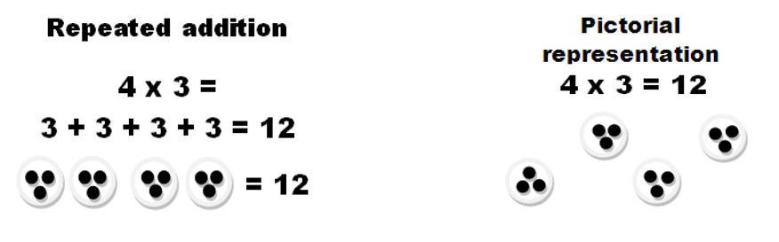
Begin by building on the understanding that multiplication is repeated addition, using arrays and number lines to support the thinking.
Arrays are an essential representation to solve multiplication problems. Pupils can count groups of objects in each row or column to find the product. They will be given a number of objects to arrange in an array of various dimensions and also be given an unknown number of objects to count by arranging in arrays.
E.g. 3 lots of 4 = 4 groups of 3
4 x 3 = 3 x 4
4 + 4 + 4 = 3 + 3 + 3 + 3 = 12
Use of concrete representations should lead to drawing pictures and arrays.
Using a number line
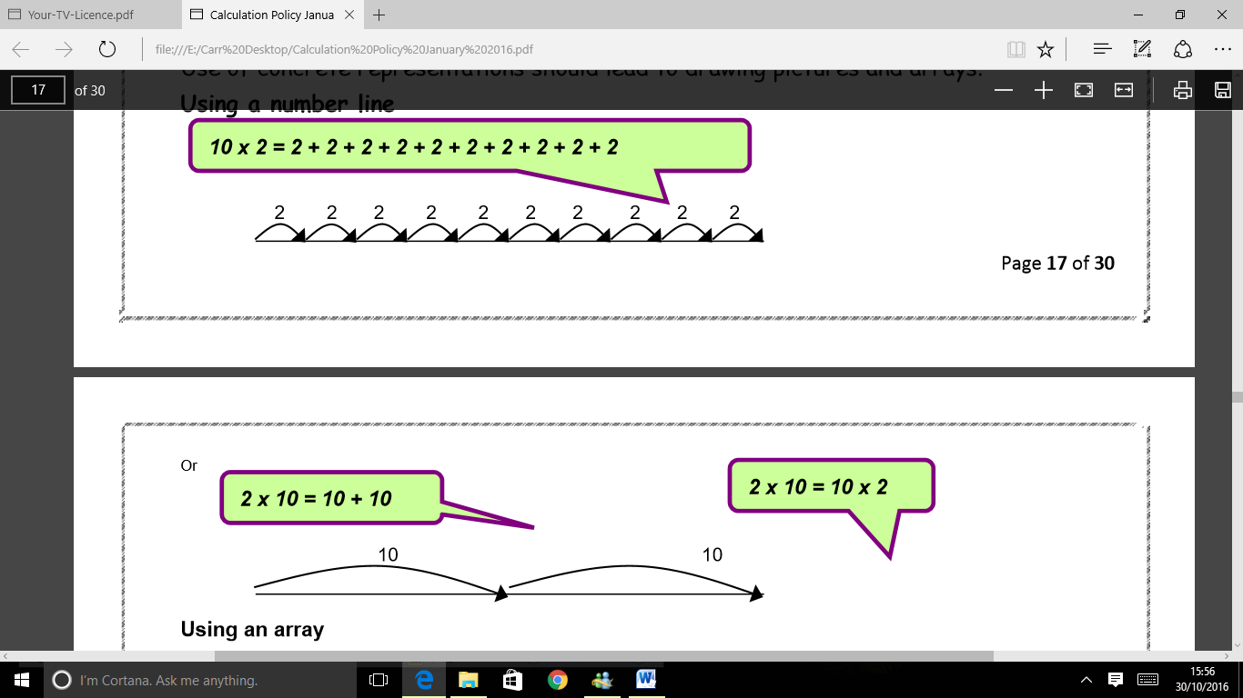
Using an array
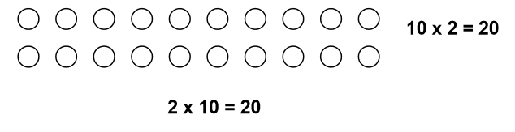
Extend the above methods to include the 3, 4 and 6 times tables then begin to partition using jottings and number lines.
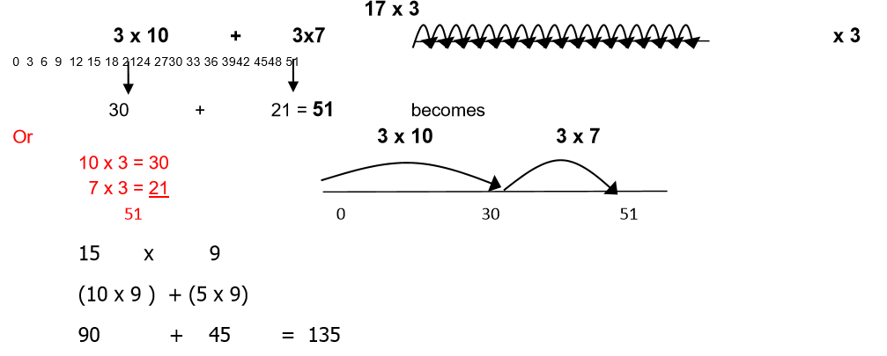
Use blank number lines to ‘draw’ the sum onto. Again pupils MUST be confident with times table facts, place value and partitioning to be able to break down the calculation.
The grid method of multiplication is a simple, alternative way of recording the jottings shown previously.
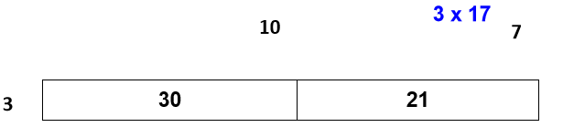
If necessary (for some children) it can initially be taught using an array to show the actual product.
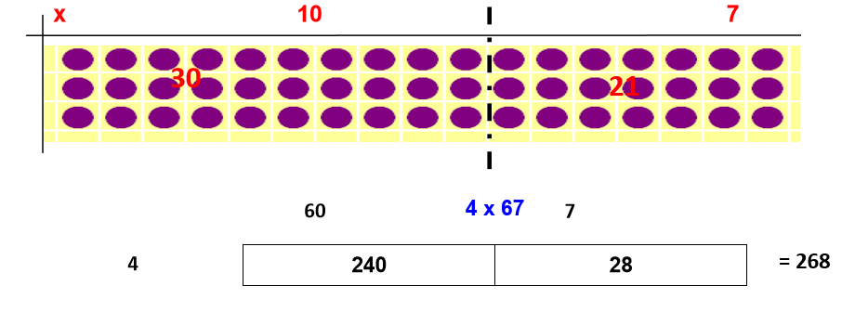
Use all tables with more complex calculations
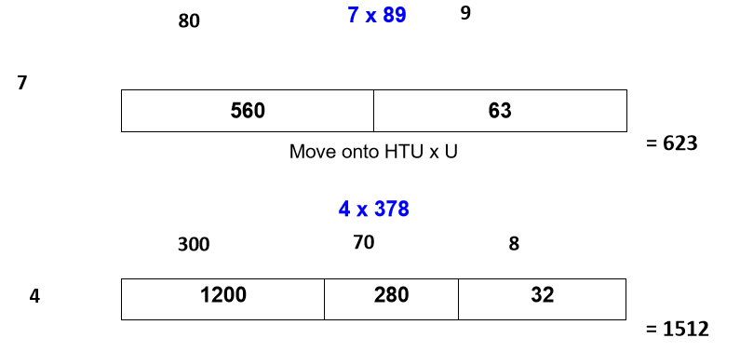
The grid method may continue to be the main method used by children when multiplying 2 digit by 2 digit and beyond into 3 digit numbers as well as right into decimals with 1 and 2 decimal places. It helps to develop a strong understanding of place value and links with multiplying and dividing with multiples of 10, 100, 100 etc
Extend the grid method to TU × TU, asking children to estimate first.
38 x 57
38 × 57 is approximately 40 × 60 = 2400.
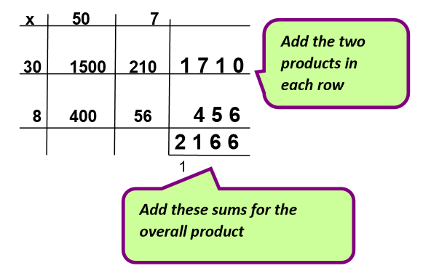
The grid method is often the ‘choice’ of many children in Years 5 and 6, and is the method that they will mainly use for long multiplication.

- Extend to ‘short’ written methods – using columns:
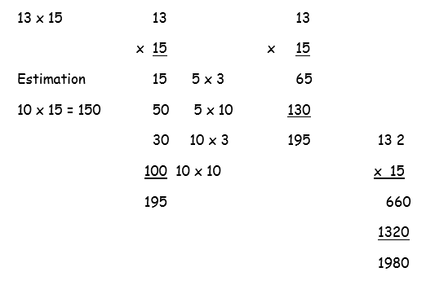
- Expanded long multiplication
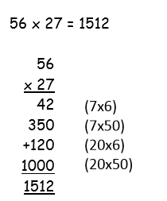
- Compact long multiplication (formal method)
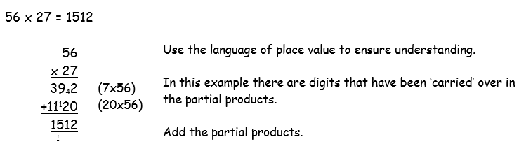
When children are confident with long multiplication extend with three-digit numbers multiplied by a two-digit number, returning to the grid method first, if necessary.
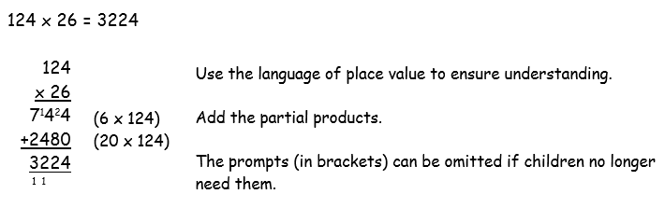
- Short multiplication (formal method):
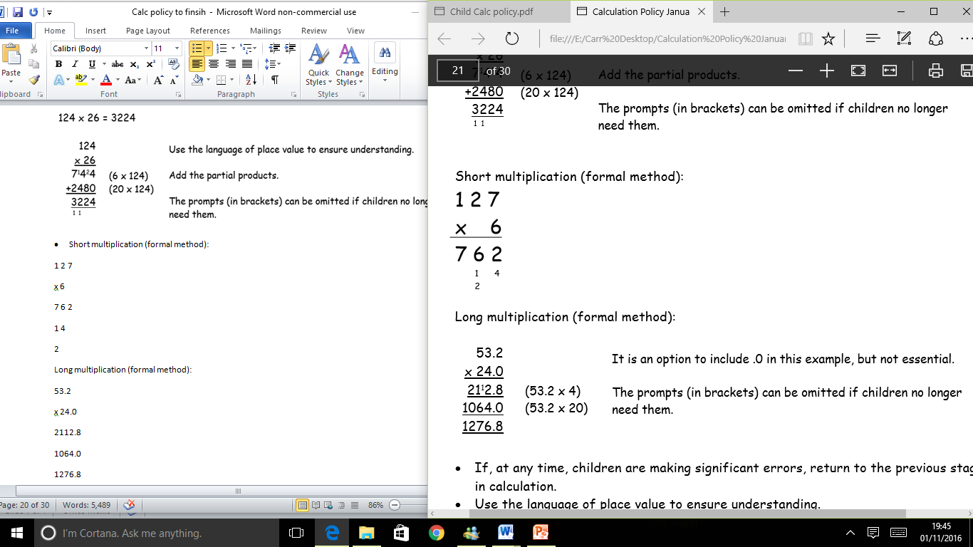
- Long multiplication (formal method):
- If, at any time, children are making significant errors, return to the previous stage in calculation.
- Use the language of place value to ensure understanding.
- Ensure that the digits ‘carried over’ are written under the line in the correct column.
DIVISION
Definition
Dividing is a quick way of subtracting several lots of the same number or quantity, or splitting it up into equal groups. Multiplying and dividing are the inverse or opposite of each other.
Early Learning
Pupils should have many practical experiences of sharing objects e.g. sharing between 2 people, or finding ½ of a group of objects. Pictures should be introduced as a next step to represent this.
Drawings and diagrams should be increasingly used to represent and demonstrate sharing.
Mental Calculations
- Counting forwards and backwards in equal steps e.g. 2’s, 5’s, 10’s.
- Rapid recall of multiplication facts.
- Partitioning.
- Secure understanding of place value.
- Multiplying and dividing by 10, 100 and 1000.
- Doubling and halving.
- Using multiplication as the inverse of division.
DO NOT LEAVE DIVISION UNTIL LAST!
Pupils do have problems developing an understanding of division.
Division should not be taught in isolation it should be integrated into multiplication and seamlessly linked so that pupils feel confident to talk about division.
One problem with division is that it can be seen in two ways as SHARING and GROUPING. It falls to the teacher and support staff to give extensive practical tasks and opportunities for pupils to grasp these concepts as well as using the correct vocabulary to interpret the pictures, jottings and written methods in answer to problems set.
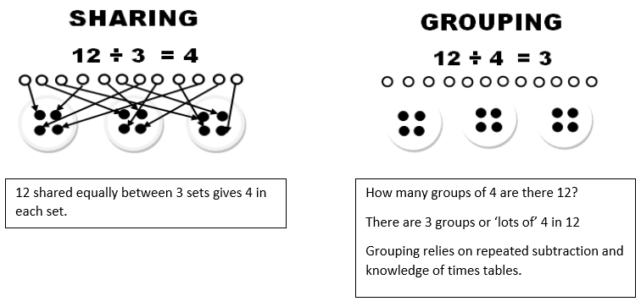
Beginning with the number line is an excellent way of linking division to multiplication. It can show division both as repeated subtraction, and as counting forward to find how many times one number ‘goes into’ another.
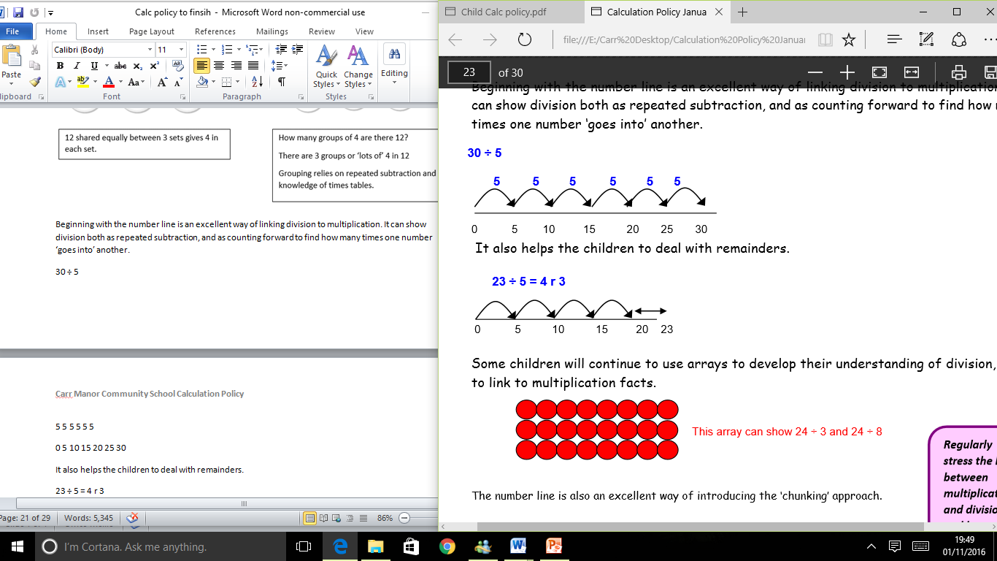
It also helps the children to deal with remainders.
Some children will continue to use arrays to develop their understanding of division, and to link to multiplication facts.
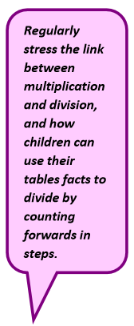
The number line is also an excellent way of introducing the ‘chunking’ approach.
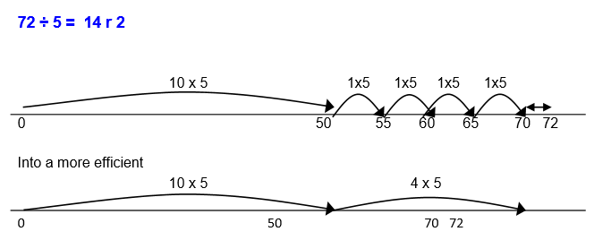
Remember, the number line method can still be used for children who find it easier to support their thinking with a visual image. They are still completing the same mental process of finding chunks of the divisor.
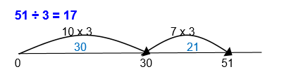
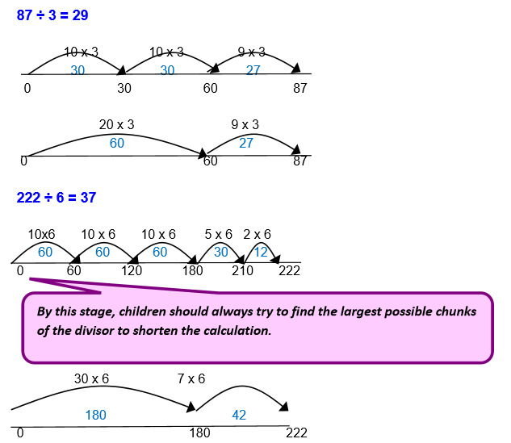
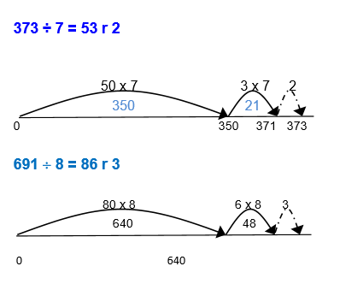
Moving onto more formal methods of division.
The number line method can be translated into the more formal long division method but pupils will need to be able to complete column subtraction confidently and know their times tables and related facts eg 3x4=12 30x4=120 etc.
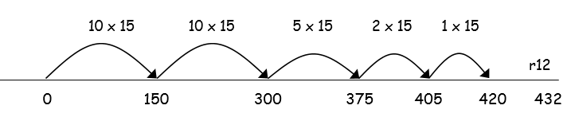
By this stage, children should always try to find the largest possible chunks of the divisor to shorten the calculation.
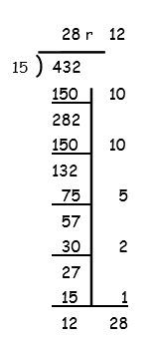
To make the long division method efficient pupils need to be able to recognise (as in the example above) that they could take out 20 lots of 15 based on times table knowledge.
When to introduce short division?
This compact method can then be introduced to improve their speed in short division.
Continue to emphasise the place value until the children are secure with this method. Children need to be introduced to a range of methods, there is no actual hierarchy. They need to be confident in all methods for division in order for them to be able to choose the most appropriate method depending on the question and the numbers involved. For example, short division may be more efficient for single digits and long division when dividing by a 2 digit number. NOTE in the Year 6 SATs will only give a method mark for recognised methods eg short or long division and sometimes the question actually states which method is required.
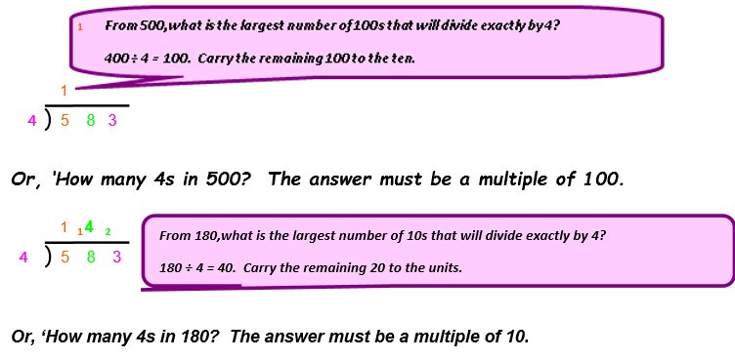
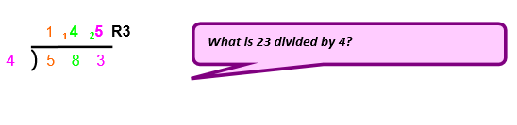
ALGEBRA
What is Algebra? Why is it important?
Algebra is a way of thinking and a set of concepts and skills that enable pupils to generalise, model, and analyse mathematical situations. Algebra provides a systematic way to investigate relationships, helping to describe, organise, and understand the world. Although learning to use algebra makes students powerful problem solvers, these important concepts and skills take time to develop. Its development begins early and should be a focus of mathematics instruction from EYFS through all key stages.
The use of the equals sign =
In Maths equality (=) means balance between two sets and inequality (≠) means an imbalance.
Algebra requires pupils to solve simple equations that involve addition, subtraction, multiplication and division with a deeper understanding of the equals symbol. Using concrete resources to start with, they should be able to explore the equality and inequality of values of numbers.
4 + 2 = ? + 3
a + b = ? + c
A helpful pedagogy to use is, ‘What’s same and what’s different on both sides of the equation?’ There must be an opportunity to experience some examples of inequality to appreciate equality in a greater sense.
7 ≠ 8 - 3 ( not equal ≠ )
In early number work, children should be encouraged to look for patterns and generalise
by drawing out similarities.
10 = 1 + 9
11 = 2 + 9
12 = 3 + 9
Add one to both sides of the equation to balance them.
b = a + c
b+1 = (a+1) + c
Later, they should be encouraged to complete the sequence to the nth term.
e.g. 5, 8, 11, 14, 17,…… so the nth term = 3n + 2
Pupils should be given the opportunity to find the unknown or the missing number in all areas of calculations.
E.g. If each banana costs 2p more than an apple, what is the cost of 3 bananas?
Price of one apple = b
A banana would cost b + 2
3 bananas would cost 3(b + 2) = 3b + 6
b 2
3 3b 6
What is the cost of 5 apples?
5 apples would cost 5 x b or 5b
Pupils should be encouraged to make connections e.g.
3 x 2 + 3 x 4 = 3 x 6
Find the missing numbers to solve problems e.g.
10 ÷ 5 = 20 ÷ a
10/5 = 20/a
Multiply both sides of the equation by 5: 5 x 10/5 = 20/a x 5
Then multiply both sides of the equation by a: 10a = 100/a x a
Finally, divide both sides of the equation by 10: a = 10
Fluency, Reasoning and Problem Solving
What does fluency, reasoning and problem solving look like in solving calculation questions?
These are the three aims from the 2014 Mathematics National Curriculum which are to ensure all pupils:
Become fluent in the fundamentals of mathematics, through varied and frequent practice with increasingly complex problems over time, so that pupils develop conceptual understanding and the ability to recall and apply knowledge rapidly and accurately
Reason mathematically by following a line of enquiry, conjecturing relationships and generalisations, and developing an argument, justification or proof using mathematical language
Can solve problems by applying their mathematics to a variety of routine and non-routine problems with increasing sophistication, including breaking down problems into a series of simpler steps and persevering in seeking solutions.
The 2014 mathematics curriculum states that ‘Mathematics is an interconnected subject in which pupils need to be able to move fluently between representations of mathematical ideas… (all) pupils should make rich connections across mathematical ideas to develop fluency, mathematical reasoning and competence in solving increasingly sophisticated problems.’
Examples of fluency, reasoning and problem solving:
8 x 5 = 40
Starting with this problem, pupils who demonstrate good fluency, reasoning and problem solving skills are able to use this fact to create others such as:
5 x 8 = 40 8 x 5 = 20 x 2 5 x 8 = (5 x 10) – (5 x 2)
40 ÷ 5 = 8 (2 x 4) x 5 = 10 x 4 0.8 x 0.5 = 0.4
40 ÷ 8 = 5 16 x 2.5 = 40 5 x 8 = 10 x 4
8 x 50 = 400 40 = 8 x 5 23x √25 = 40 = 8 x 5
80 x 50 = 4000 5 x 8 = 8 + 8 + 8 + 8 + 8 40 x 8 = 5

The Six Rs of Oral and Mental Work Six Rs Learning Focus Possible activities
Six Rs | Learning Focus | Possible Activities
Rehearse | To practise and consolidate existing skills, usually mental calculation skills, set in a context to involve children in problem solving through the use and application of these skills, use of vocabulary and language of number, properties of shapes or describing and reasoning. | Interpret words such as more, less, sum, altogether, difference, subtract; find missing numbers or missing angles on a straight line; say the number of days in four weeks or the number of 5p coins that make up 35p; describe part-revealed shapes, hidden solids; describe patterns or relationships; explain decisions or why something meets criteria.
Recall | To secure knowledge of facts, usually number facts, build up speed and accuracy, recall quickly names and properties of shape, units of measure or types of charts, graphs to represent data. | Count on and back in steps of constant size; recite the 6-times table and derive associated division facts; name a shape with five sides or a solid with five flat faces; list properties of cuboids; state units of time and their relationships.
Refresh | To draw on and revisit previous learning; to assess, review and strengthen children’s previously acquired knowledge and skills relevant to later learning; return to aspects of mathematics with which the children have had difficulty; draw out key points from learning. | Refresh multiplication facts or properties of shapes and associated vocabulary; find factor pairs for given multiples; return to earlier work on identifying fractional parts of given shapes; locate shapes in a grid as preparation for lesson on coordinates; refer to general cases and identify new cases.
Refine | To sharpen methods and procedures; explain strategies and solutions; extend ideas and develop and deepen the children’s knowledge; reinforce their understanding of key concepts, build on earlier learning so that strategies and techniques become more efficient and precise. | Find differences between two two-digit numbers, extend to three-digit numbers to develop skill; find 10% of quantities, then 5% and 20% by halving and doubling; use audible and quiet counting techniques to extend skills; give co-ordinates of shapes in different orientations to home concept; review informal calculation strategies.
Read | To use mathematical vocabulary and interpret images, diagrams and symbols correctly; read number sentences and provide equivalents, describe and explain diagrams and features involving scales, tables or graphs; identify shapes from a list of their properties, read and interpret word problems and puzzles; create their own problems and lines of enquiry | Tell a story using an interactive bar chart, alter the chart for children to retell the story; start with a number sentence (eg 2 + 11 = 13) children generate and read equivalent statements for 13; read values on scales with different intervals; read information about a shape and eliminate possible shapes; set number sentences in given contexts; read others’ results and offer new questions and ideas for enquiry.
Reason | To use and apply acquired knowledge, skills and understanding; make informed choices and decisions, predict and hypothesise; use deductive reasoning to eliminate or conclude, provide examples that satisfy a condition always, sometimes or never and say why. | Sort shapes into groups and given reasons for selection; discuss why alternative methods of calculation work and when to use them; decide what calculation to do in a problem and explain the choice; deduce a solid from a 2-D picture; use fractions to express proportions; draw conclusions from given statements to solve puzzles.

